Taxonomy of Number
Vincenza Antonetta Berardo

Thesis: Throughout Metaphysics M, Aristotle systematically tests different categories of number against his “separability” criterion, in order to show that mathematicals, in spite of Plato’s best efforts, cannot exist separately from sensibles. This testing follows a taxonomy which, although not explicitly described in Metaphysics M itself, we can reproduce the shape of via a careful exegesis of the text.

- Introduction
- Separability Criterion
- Magnitudes vs Numbers
- Mathematical Number, not Magnitudes
- The Cuts
  - Ideal Number vs Mathematical Number
  - Composite vs Non-Composite
  - Comparable vs Non-Comparable
  - Intra-Kind vs Inter Kind
  - Annas’ Cuts
- Arguments Against Form Number
  - Ideal Non-Composite
  - Ideal Composite Non-Comparable
  - Ideal Composite Comparable Intra-Kind
  - Ideal Composite Comparable Inter-Kind
- Arguments Against Mathematical Number
  - Mathematical Non-Composite Number
  - Mathematical Composite Number
- Conclusion
Introduction
Throughout Metaphysics M, Aristotle systematically tests different categories of number against his “separability” criterion, in order to show that mathematicals, in spite of Plato’s best efforts, cannot exist separately from sensibles. This testing follows a taxonomy which, although not explicitly described in Metaphysics M itself, we can reproduce the shape of via a careful exegesis of the text. This paper will do that.
There are a few things this paper will not do, but could be areas for further exploration.
- A careful read of Annas’ text on Metaphysics M and N with an exhaustive analysis showing why my split of Ideal Number and mathematical number is the correct way to read M, whereas her split of magnitudes and arithmetic number, although one distinction which appears throughout the text, isn’t the distinction important to Aristotle’s taxonomy
- Take the numbers which Aristotle either doesn’t address or dismisses wrongfully and build a more systemized ontology of Platonic number onto Aristotle’s rigorous scaffolding.
I disagree with Annas’ interpretation of M in several key places, but for the sake of focus will merely gesture at them, rather than build an entire argument focused on this. For (2), by the end of this paper we will have examined all the types of number within Aristotle’s taxonomy and will be able to list them comprehensively.
This is a survey into how Aristotle taxonomizes number in Metaphysics M. To this end, first I will explain very briefly the “separability” criterion which Aristotle uses throughout M. Then I will define two different types of number, continuous and discrete, the distinction between which actually obfuscates Aristotle’s operative distinction throughout the book. Next I will explain exactly that issue: why the operative distinction is between Ideal and mathematical numbers, not magnitudes and arithmetic number, and how that confusion arises. The main focus of the paper is what divisions Aristotle makes to create his taxonomy for the numbers. I will then place all the arguments in Metaphysics M into these categories as much as is possible. In the end, then, we will be left with a clear picture of where to cut numbers at the joints, thus informing future examinations of number theory in the ancient world.

Separability
First, a short exegesis on the separability argument. Aristotle sets up a trichotomy (which, through lack of attention for the third option, turns in effect into a dichotomy) for the mode of number’s existence: either it is in sensible objects, separate from sensible objects, or some third mode of existence. Sensible compounds are inseparable and movable, while his candidate for substance must be something separable and immovable. Numbers meet the “immovable” criterion, but not the “separable” one. The geometer’s triangle doesn’t degrade over time, its angles growing less acute or points dulled. But as for separability, Aristotle leaves this an open question until Metaphysics M. For mathematical objects to be a candidate for substance they must be separable from sensible compounds; if they are inseparable, mathematicals must not be substance. Aristotle will go on to conclude that all number falls short of this second criterion of substance.

Magnitudes vs Numbers
This separability criterion is the criterion that Aristotle tests his arguments against throughout Metaphysics M. The goal of this paper isn’t to analyze whether or not these arguments work, but keeping in mind this separability criterion will help us see the shape of Aristotle’s arguments and why he concludes them when he does. Before we look at the major distinction I argue Aristotle makes throughout Metaphysics M, let’s look at another distinction which, although important, at times can obscure the more important dichotomies.
There are two types of number in Ancient Greece: continuous, or magnitude, and arithmetic, or “number” (άριθμούς). Continuous number is the type of number which the Greeks understood to be the magnitude or line in geometry. On the other hand is arithmetic number, which Aristotle just calls “number.” This is associated for Aristotle with the unit in the same way continuous number is associated with the line.
However, continuous versus arithmetic number is not the key the distinction that matters in Metaphysics M. Aristotle repeatedly states that he is not doing anything different with magnitude or number, by gesturing at one or the other type when he has gone on for a while with a single example. The point is not that something different happens with magnitudes versus number, it is that he uses magnitude more heavily as his example of mathematical number, and number more heavily as his example of ideal number. This is the distinction that is key in Metaphysics M. Chapters 6-8 aren’t about “Forms as numbers?” or “numbers as Forms?” but about this very specific classification of numbers which are Form-Numbers; this is in contrast to the class of number he discusses in Chapters 1-3 which are mathematical numbers.

Mathematical Number, not Magnitudes
This is where I diverge from the orthodoxy and have to disagree with Annas at some points. M2 is mostly about mathematical number and not Ideal Number. I’m not interested in directly arguing this at the moment, but I will try to briefly show why M2 is about mathematical number in contrast to Ideal Number.
Aristotle often gets accused of being particularly uncharitable to Plato in Metaphysics M. But he actually, at the very least, appears to be sticking quite closely to Plato’s own categories of noesis, dianoia, and the sensibles, by talking about Ideal Number, mathematical number, and sensible numbers, all as separate entities. Chapters 1 and 2 of M both deal with mathematical number. Chapter 1 sets up this contrast between Ideal and mathematical numbers as the major distinction Aristotle will be addressing throughout M. “And since some recognize these as two different classes—the Ideas and the mathematical numbers…”
Then, after setting up this dichotomy, Aristotle goes into first examining mathematical number, in chapter 2. At times Aristotle will say “objects of mathematics” or “mathematical objects”, but I propose that you should read this as referring to the specific object-class of things which are on the “mathematical” side of the “Ideal/mathematical” split. Reading it this way resolves a lot of confusion that is characteristic of Met M, which I’ll point out as we go through these arguments.
I’m not sure how to demonstrate this other than by overwhelming evidence, so with that in mind, here follows a comprehensive list of every time in M2 Aristotle mentions mathematical number or mathematical objects (as opposed to Ideal Number or Ideal Objects, i.e., Forms):
“That it is impossible for mathematical objects to exist in sensible things and at the same time that the doctrine…”
“Therefore these will be planes and lines other than those that exist along with the separate mathematical solids; for the latter exist along with the mathematical solids, while the others are prior to the mathematical solids.”
“Now the accumulation becomes absurd…those which exist apart from the sensible planes, and those I the mathematical solids, and those which exist apart from those in the mathematical solids… with which of these, then, will the mathematical sciences deal?”
“And the same account will apply also to numbers… so that there will be various classes of mathematical numbers.”
“Here then we shall have another substance intermediate between, and separate from, the Ideas and the intermediates…”
“…if one supposes the objects of mathematics to exist thus as separate entities…”
“Again, what in the world will make mathematical magnitudes one?”
“But in the case of the objects of mathematics, which are divisible and are quantities…”
“Again, the modes of generation of the objects of mathematics show that we are right.”
“It has, then, been sufficiently pointed out that the objects of mathematics are not substances in a higher sense than bodies are…”
“….it is true also to say, without qualification, that the objects of mathematics exist, and with the character ascribed to them by mathematicians.”
With the added context of M2, it would appear that every time Aristotle picks out the object of his arguments in M2, it is in fact mathematical number. This will be in stark contrast to M6-8, where he picks out Ideal Number as the object of his arguments. This is also in contrast to M4-5, where Ideal Object, AKA Forms, are the focus of his arguments.
The key distinction in Metaphysics M is not between magnitudes and arithmetic number. It is between mathematical number and Ideal Number. It just so happens that Aristotle used mainly magnitudes to illustrate his arguments against mathematical number, and mainly arithmetic number to illustrate his arguments against Ideal Number. But we know that magnitude and arithmetic number cannot be the primary division of Metaphysics M, because he gestures at both of them in the two separate sections of M (1-2 and 6-8).
In M2, after Aristotle goes through an accumulation argument, he says “[a]nd the same account will apply also to numbers; for there will be another set of units apart from each set of points…” Both magnitudes and arithmetic number fall under the category of mathematical number, because of course, they would have to (whether or not this argument is actually effective against discrete number, much less magnitude, is beside the point). Later, in M6, Aristotle does the exact same thing in reverse: after a long argument about number and unit, he says “The ease of lines, planes, and solids is similar… for they say that neither is every spatial magnitude divisible into magnitudes, nor do any two units make two.” Therefore the distinction between the beginning chapters of M and the latter chapters isn’t that in one he’s discussion magnitude and in the others he’s discussing units, but rather, like he says in M1, “…the Ideas and the mathematical numbers…”

The Cuts

Ideal Number vs Mathematical Number
There are two different types of number Aristotle ascribes to Platonists: Ideal Number and mathematical number. This distinction is separate from magnitude and arithmetic number. Both Ideal Number and mathematical contain within them magnitude and arithmetic number. Ideal number is Form-number, aka an object of noesis. Form numbers are not addable, dividable, &c; they are objects of noesis; they are singular (aka, there is only one of each). And they are uncomparable, or uncombinable, to use Annas’ translation. Contrast this with mathematical numbers, which are combinable/comparable, objects of dianoia, are non-unique in that there can be more than one of them &c. Both continuous number and discrete number ought to have these two different modes of existing as number, in order for mathematicians to be able to do math as they do. For instance, for mathematicians to draw up a proof of the Pythagorean theorem, they need to use multiple lines and squares, but they have to be “perfect” squares, in the sense that all their angles are indeed 90 degrees and their two sides are perfectly parallel to each other, &c.
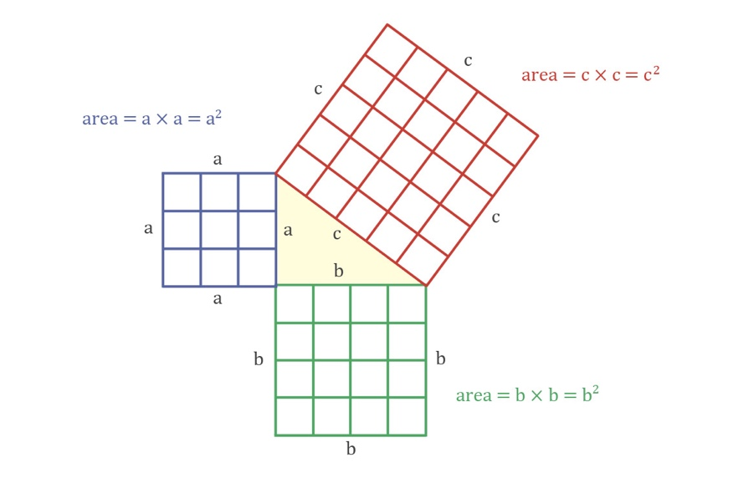
Any drawn, or sensible, square cannot possibly be perfect in all these ways, hence the need for mathematical number, which is the number those sensible lines are meant to be pointing to. At the same time, these lines and squares cannot be Forms, because there are multiples of them in the proof of the Pythagorean theorem. There are three squares in that proof, but there’s only one Form of Squareness (a perfect square which has no specific side length because it is all squares of all side lengths). Each square in that proof is made up of four lines of equal length, but again, these lines could not be the Form of three feet or five feet, because there is only one Fiveness which doesn’t have the specific position of being parallel to another or meeting another at a right angle, &c.

Composite vs Non-Composite
Both Ideal and mathematical numbers can be subdivided into composite and non-composite numbers. Composite numbers are composed of more than one thing, versus non-composite, which are a single unity. Forms, according to a traditional reading of Plato, are non-composite. The Form of Beauty is non-partite and is not made up of all the beautiful paintings and sunsets in the world, but is just one Beauty, wholly itself by itself. This is especially hard to conceive with numbers, because something like “Six” seems necessarily to be composed of other numbers: six units, two threes, three twos, half of Twelve, &c. But if it is to be a Form, and Forms are non-composite, then it ought to be just: Six, itself by itself, unified. The translation “Sixness” gives this sense better than “Six,” since the concept of number is so intuitively composite.
On the other hand, Aristotle presents us with this division in Ideal Number, with non-composite Ideal Number as one thing and on the other side composite Ideal Number. From 1080a12-1083a18, Aristotle states fairly clearly that he’s examining what he understands to be Ideal number. At 1083a19 he examines mathematical number in the same manner, meaning that those arguments in Met M 18012-108318 ought to be about subdivisions in Ideal Number, not mathematical number. Which means Aristotle can reasonably make the division of non-composite and composite Ideal Numbers; that is, Form-Numbers which are made up of something—unit is the likely candidate, though what properties these units have are the focus of his next two cuts. Although all these divisions should apply equally to mathematical and Ideal Number, Aristotle only really describes the following divisions in Ideal Numbers, so the descriptions will follow that track for ease of reading.

Comparable vs Non-Comparable
The next division is of Ideal composite Numbers (because non-composite Numbers are, most likely, without any more natural divisions aside from the individual members of their set). Taking units as the best candidate for what composes Ideal composite (arithmetic) Numbers, Aristotle examines some of the differentiating properties of these Numbers. The first is whether or not the units within any given Ideal composite Number are comparable to one another or non-comparable (this word could also be translated “combinability” and “non-combinability” which may make this explanation easier to understand). Then the concern is for those Ideal Numbers made up of units, whether or not those units can combine with each other. The non-comparable Ideal composite Numbers are very close in nature to the non-composite ideal numbers, since their units are fixed and just of one kind.
It is hard to understand how Aristotle conceives of a number composed of non-combinable units, but perhaps a “bunching”, a roughshod concept of a set, even, is meant to be our touchstone here. There’s a bunch over here and that bunch is Five and it is composed of pieces within that bunch but those pieces aren’t five Ones which add together to Five. Maybe something like the difference between a mixture and a solution is what we’re meant to picture: oil and vinegar form a mixture, salt and water a solution, oil and vinegar form a composite of “salad dressing” with non-combinable parts, while salt and water form a composite of “salt-water” with combinable parts.

Intra-Kind vs Inter-Kind
This refers to the way that units within a Number are able to combine, or not, with units of other Numbers. As we previously discussed, non-composite numbers do not have units to ask whether or not the Numbers are comparable. Similarly, we can’t divide numbers with units which are non-combinable into this next subcategory, because their units are non-combinable. But of the types of Numbers which are a) composed of units, and b) composed of units which can combine with each other, Aristotle draws a distinction between composite Numbers with units which are combinable either a) within only their own Number, or b) within any other Number.
For intra-kind combinable composite ideal numbers, although Six may be made up of units, and those units may all come together to form the number Six, they are Six!Units, distinct in kind from Five!Units, and not combinable with the Five!Units.
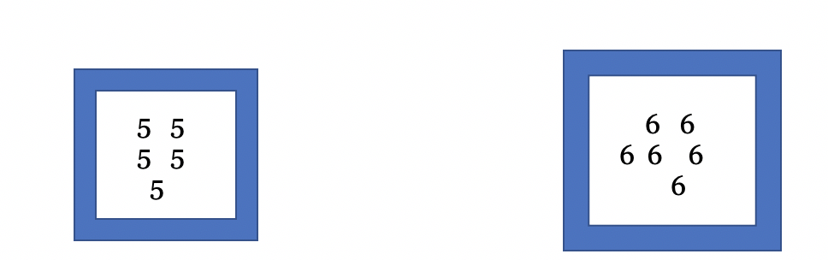
The units that make up the Ideal Number Six are of the five-sort of units and could not be taken to make up the Ideal Number Six. In other words, Six is not made by taking Five and adding One (note the capitals, the capitals are important).
On the other hand, for inter-kind, combinable composite Ideal Numbers, the units are all the same no matter what number they are in. Therefore you can create Six by adding Single Unit to Five, because the stuff which makes up all the Ideal Composite Combinable Numbers are the same stuff; that is, undifferentiated (non-unique, i.e., not of the “Five-sort” or “Six-sort”) unit.
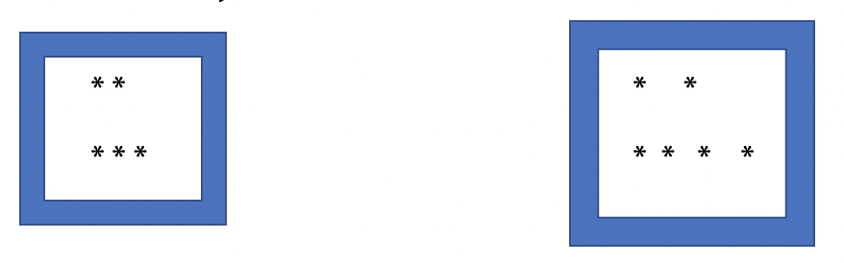
The problem with this, Aristotle states outright when he describes the subcategory, is that this sort of Ideal Number—composite comparable intra-kind—is actually just mathematical number, not a proper subcategory of Ideal number.
These then are our cuts. Now that we have these, we can categorize Aristotle’s arguments against Platonic number (more precisely: against any category of number being separable from sensibles) based on where in our taxonomy the argument will fall.

Annas’ Cuts
In Metaphysics M Aristotle systematically tests these different kinds of numbers to determine if they’re separable from sensibles, and ultimately show that none of them are. At the very beginning of M6 he lays out of the 3-ish types of Ideal number he examines. As Annas understands them (names added by me), they are:
- Intransitive counting: ordered series, and numbers differ from each other via their position in the series, not by thing they reference. These numbers are non-combinable with each other, they are unique positions in a series.
- Tally marks: counting as actually a series of units succeeding each other, they are all combinable, and there is no difference between one unit and another.
- Partite Form-Numbers: unique kinds, non-combinable with each other, though within a number-kind (aka, 5) those units which comprise it are combinable with each other (thus making up the number).
Annas states that types 1) and 2) are just special definitions of Form-number. However under my partition the underlying system is clearer: these are all kinds of Form-Numbers, just different subcategories of Form-Numbers. It is not odd or confusing that Aristotle has these two, almost indistinguishable types of Form-Numbers in M6-8; of course he does, these are the chapters where he critically examines Form-Numbers. This explanatory power is a strength of my map of Metaphysics M.
For clarity’s sake, first I will go through Form Number, because the taxonomy Aristotle establishes in M is most evident in these sections (M6-8). Then, once we’re well-versed in and can recognize easily Aristotle’s system, I’ll go back to M1-2, where Aristotle examines mathematical number. The categories are less clear here, but still present. First, let us categorize Aristotle’s arguments against Form Numbers and show how they form the shape of his taxonomy as we go.

Arguments Against Form Number Being Separable

Ideal Non-Composite
Aristotle doesn’t address this type of Ideal Number at any great length. Arguably, this would be the most “Platonic” of all the Ideal Number types, because they are non-composite. If there are Forms of numbers (Twoness, Triangularity, &c.), then they ought to share the characteristics of all other Forms, which would be whole completeness, itself-by-itself, not made up of other things. In that case, they’d be Ideal non-composite numbers. Very briefly Aristotle in fact seems to state that any mathematical realists (excluding the Pythagoreans) believe Ideal numbers to be composite: “All who say the 1 is an element and principle of things suppose numbers to consist of abstract units.”
It may be that here Aristotle takes the fact that Platonists posit the mathematical numbers as existing as be a composite story of Ideal number. I mean by this that I think Aristotle is describe a taxonomy where Ideal Numbers can be broken up into mathematical numbers, mathematicals being posterior to them according to Plato, and therefore Ideal Numbers are not non-composite. That picture would look like this:

To be clear, I believe Aristotle is accusing Plato of this poor taxonomy, not that Aristotle’s taxonomy is set up this way. And it almost makes sense as a description of the Platonic ontology: if you take the divided line literally as object-class descriptions, this taxonomy fits that description. Perhaps this is why Aristotle never addresses the number class of Ideal Non-Composite numbers: he doesn’t think they exist on the Platonic picture. But this is an important category of number which does exist if the Aristotelian taxonomy I’ve given is accurate, because it is the best candidate for what ought to be the Platonic conception of Ideal number. But again, Aristotle largely ignores this category of Ideal Number.
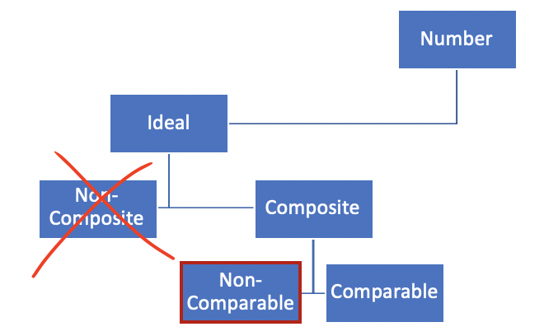

Ideal Composite Non-Comparable
Ideal composite non-comparable Numbers are ordered series numbers, Numbers which do not refer to any sensibles. Rather than refer to 10 oxen, these Numbers are reference-less counting numbers: 1, 2, 3… These Numbers differ from each other via their position in the counting series only. Annas calls these intransitive counting numbers. Aristotle has several arguments as to why these Numbers are not separable from sensibles.
First, Aristotle argues Ideal composite non-comparable Numbers can be neither Ideal Number nor mathematical number. There is another type of number, of course: sensible number. Recall that the purpose of M is to try and find a number which is separable from sensibles. Any time Aristotle can demonstrate that a category of number as merely sensible, he can stop arguing. If Aristotle’s argument here is valid, then that means Ideal composite non-comparable Numbers are not Ideal Numbers but merely sensible numbers, and therefore not separable from sensibles. Remember that the purpose of this paper is not to evaluate these arguments on their merits but use them to build this taxonomy.
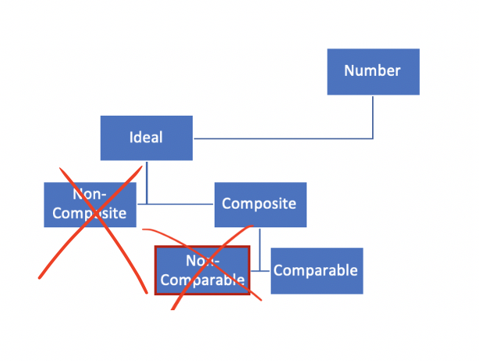
The next paragraph is another argument (possibly the same argument, possibly a different one) against Ideal composite non-comparable units. In this theoretical view, units, although non-comparable, are addible. They are uniquely identified by their position in a series. Paragraph 4 of M7 continues with another (probably distinct) against this class of number, this time an argument about generation. That is his final argument against this type of number, concluding that indeed, this subcategory of number is impossible and doesn’t exist; or at least, not separately from sensibles. After this, in paragraph 5, Aristotle moves onto the next type of Ideal composite Number: ones that are composed of comparable units (sometimes Aristotle calls these “undifferentiated” units).
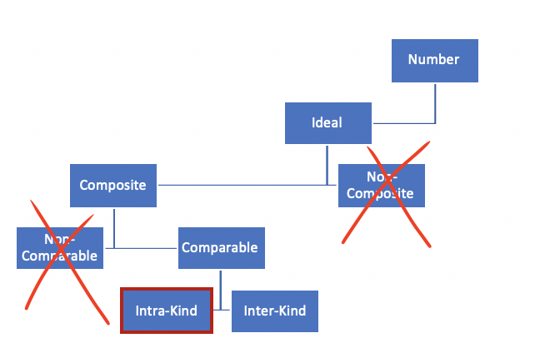

Ideal Composite Comparable Intra-Kind
Next, Aristotle examines Ideal composite Numbers whose units are comparable. But there are two different ways for things to be comparable: intra-kind or inter-kind. Intra-kind is a number where the units which compose it are only combinable/comparable within itself. For example, the units which make up Six can combine to successfully make Six, but those units are Six!units, which are not combinable with Five!units, because they are unique in kind.
Aristotle levies several arguments against intra-kind comparable composite Ideal Numbers. The first is that there would be multiple 5’s within a 10 (Annas helpfully calculates this as 252 different 5’s). The next is that there would be the potential for non-native 2’s to be within a 4. And of course, Aristotle raises again the more general question of how anything which has multiple 5’s or 2’s within it, composing it, could be considered a “unity.”
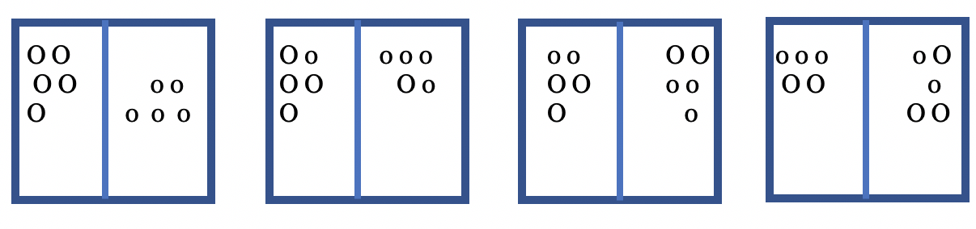
(Here seems like a good time to note: this is exactly why the correct Platonic taxonomy of Ideal Numbers is Ideal-Non-Composite Number. Ideal Numbers are unities because they are non-composite. As soon as Aristotle starts going down that “composite” branch of the Ideal Number tree, he is in mathematical number, not Ideal Number.)
The final argument Aristotle makes against the particular class of composite intra-kind comparable Ideal Numbers is that all things which are composed of Ideas are composite, and since he’s already arguing that there are Ideal Numbers which are composite, they are composite of other Ideas, reduction ad absurdum. Again, this absurdity is brought on by trying to discuss composite Ideal Numbers at all, but I’m not evaluating these arguments on their merit. Also Annas calls this argument a “bafflingly bad” one.
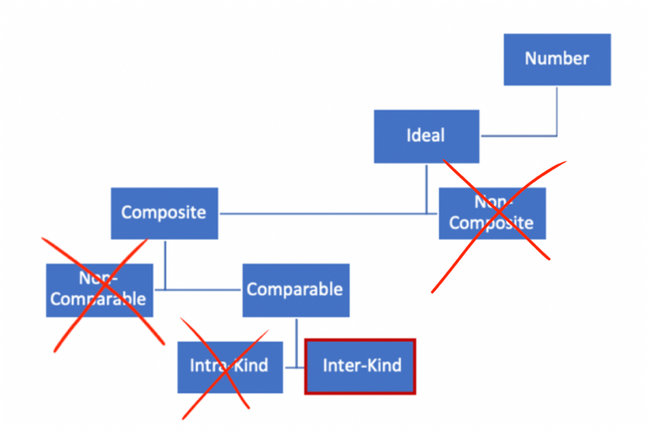

Ideal Composite Comparable Inter-Kind
The last subcategory for Ideal Number is composite comparable inter-kind. This is the category which, at the beginning of M7, Aristotle states must not be an Ideal Number but is actually just a mathematical number in disguise. But he demonstrates these arguments anyway, because according to his taxonomy there is a category here.
These are Ideal Numbers conceived of as having units which are basically just tally-marks. Unlike the Ideal Numbers which had units which were only comparable intra-kind (the Five!Units were not combinable with the Six!Units), in this sort of Number all units are the same and thus comparable intra-Number. So Six is made up of six units, and Five is made up of five units, and those units in the Six are no different from the units in the Five.
But here is where the problem lies: if the units are undifferentiated, then, how are there differentiated numbers of any sort? The first argument is the differentia problem: (i) difference in Number can’t boil down to difference in unit, because units are non-differentiable, and (ii) two numbers of the same units will be the same number. Again, this argument makes a kind of sense when you remember these are Ideal Numbers, not mathematical numbers. In mathematical number there can be multiple 6’s; in Ideal number there is only Six. The second argument is the problem of multiple Twoness’s. There would be sets of two units that they will refuse to call Two, which sounds counter-intuitive.
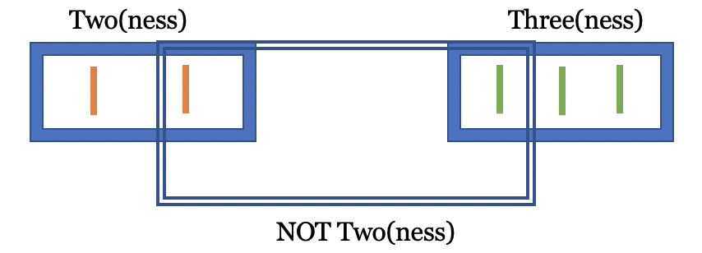
One final piece of evidence that these arguments have been focused on Ideal Number rather than mathematical number is that Aristotle reasserts that Plato has to have Forms of Numbers in his ontology.
Following this, last argument Aristotle makes against inter-kind comparable composite Ideal Numbers is the quality/quantity argument. Basically, if we have undifferentiated unit, but differentiated Numbers, then the differentiation has to come from somewhere. Then do the units which make up the Numbers differ in quantity or quantity? They can’t differ in quantity, because that would lead to absurdities:
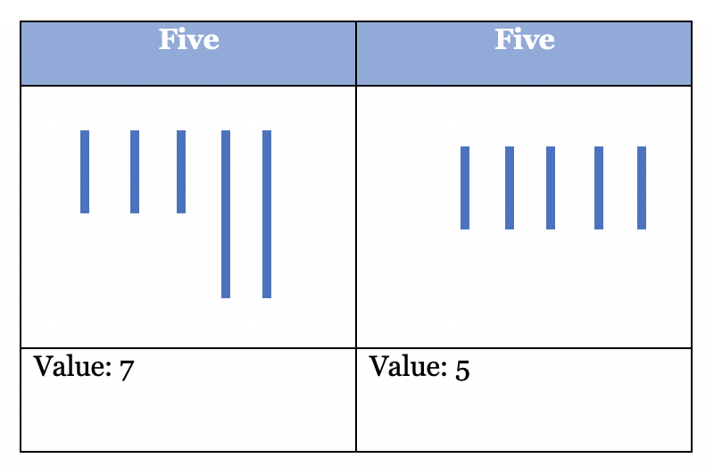
At the same time, the units can’t differ in quality, because nothing which the units are generated from have “quality.” Therefore, there can be no Ideal Numbers which are composed of undifferentiated units.
Finally, a little earlier in the text (at the end of M7), Aristotle works backward up his taxonomy: it seems combinable units are impossible for Ideal Number, because both inter- and intra-kind are either impossible or actually just mathematical number. Therefore it makes sense that Plato insists on non-comparable units for his Form Numbers, which Aristotle acknowledges is the way the Platonists would have to go. He does not however discuss non-composite Form Numbers—there is a small line where he says “…nor can a number be an Idea, for one Idea will be in another, and all the Forms will be parts of one Form,” which is perhaps meant to say that any Ideal Number would necessarily lead to Ideas all being composite, which would be bad for the Platonists since Ideas are supposed to be wholly themselves-by-themselves. But that is a reference back to the argument which Annas describes as “bafflingly bad,” so it is not worth much reprised here.

Arguments Against Mathematical Number
Plato has (at least) two kinds of numbers in his ontology, according to Aristotle: Ideal and mathematical. Aristotle systematically demonstrates in M6-8 that Ideal Numbers are inseparable from sensibles. He must also then demonstrate that mathematical numbers are inseparable from sensibles. This is the aim of Aristotle’s arguments in M2.
Mathematical number are what Aristotle calls intermediates under the Platonic ontology. There are Ideal Numbers, which are Form-Numbers with all that entails: complete, whole, itself-by-itself, changeless, singular, &c. But given these sorts of characteristics of Forms, if Sixness and Triangularity are of this nature, then Platonists would have to posit mathematical intermediates to describe the objects used by mathematicians. If I want to prove the Pythagorean theorem, I have to use three squares, so I can’t be using the Form of Squareness, which is singular. Mathematical numbers are perfect (unlike a sensible square I might draw, mathematical squares are always all right angles, all perfectly equal sides, &c.) but can be multiple. The same taxonomy which applied to Ideal Number then should fit onto mathematical number.

Mathematical Non-Composite Number
Mathematical non-composite numbers are mathematical numbers (in contrast to Ideal Numbers) which cannot be broken down into parts. A non-composite cube would not be made up of six planes and twelve lines and eight points, but simply be a cube “unity.” It is a single thing which just is a cube, not composite of lesser entities. Aristotle begins M2 with this distinction, between composite and non-composite mathematical number. He states that the non-composite is prior to the composite as the first step to a longer argument. The details of the argument itself are not important right now, only that they can map onto this numeric taxonomy. Aristotle draws this distinction, between composite and non-composite, within the context of the discussion of mathematical numbers (both geometric and arithmetic). The options as he presents them are composite mathematical number and non-composite mathematical number.
The first argument Aristotle levies against non-composite mathematical number is that non-composite mathematical numbers are prior in formula but not being to sensibles. They are also prior to composite mathematical number. Again, the quality of the argument doesn’t matter, just the fact that he makes it. Aristotle then proceeds to develop from this an obscure argument which ostensibly shows that although non-composite mathematical number is prior to both composite mathematical number and sensibles in formula, they are not prior in being, and therefore are not separable from sensibles. Again, the conclusion that this sort of number is inseparable from sensibles is the goal of Aristotle’s arguments, so he can stop here. This is not to say that non-composite mathematical number doesn’t exist, but merely that it exists inseparably from the sensibles. Now Aristotle must examine composite mathematical number to see if it offers a better case for being separable from sensibles.
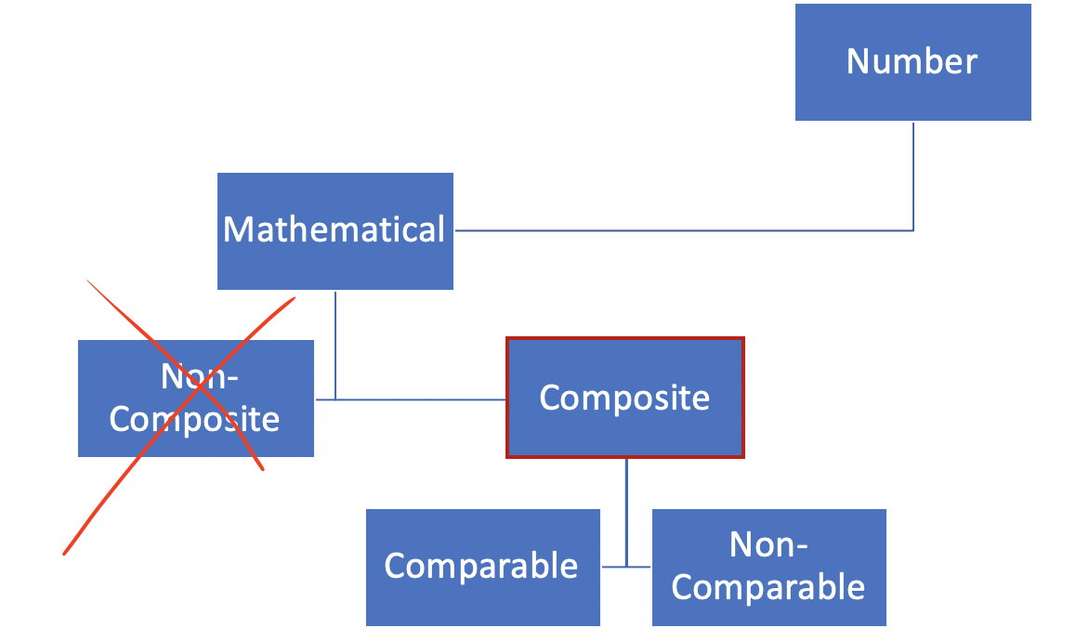

Mathematical Composite Number
Composite mathematical number makes more intuitive sense than non-composite mathematical number: of course we would expect mathematical number to be composite. After all, how does adding happen? Or construction of solids? In the case of geometric number this composition would be of lines and points and planes; in arithmetic number the unit. But this raises a problem for composite mathematical number: if a cube is definitionally a thing composed of six planes and twelve lines and eight points, how then is it a unity? Definitionally, composite mathematical number is… composite, so if what it takes for something to be separable from sensibles is unity, then yes, composite mathematical number would be inseparable.
The next line of argument Aristotle takes is to examine the things which compose composite mathematical number. Unlike Ideal Number, Aristotle does not split this into comparable or non-comparable units, but stops at the level of naming planes and lines. This is because his argument against composite mathematical number being separable from sensibles works without have to draw any further distinctions. He states that it would seem bizarre to call planes or lines “substance,” because they are definitionally non-material: if a line is defined as without breadth or depth, and material is defined as occupying space, then the notion of lines being material is clearly absurd.
Finally, there is also the previous argument, that of priority. If composite mathematical number is posterior to non-composite mathematical number in formula and being, then composite mathematical number has no claim to greater ontological primacy than non-composite mathematical number.
Arguably, Aristotle never ventures further down the taxonomy tree with mathematical number, stopping here with composite number and non-composite number. He shows first that non-composite mathematical number cannot exist separately from sensibles via his priority argument. Then he shows that composite mathematical number cannot exist separately from sensibles via his unity argument, and also because they are posterior to non-composite mathematical number anyway.
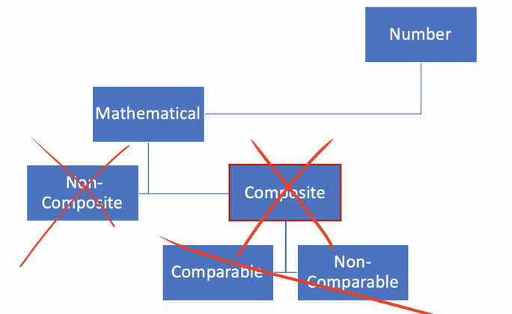

Conclusion
Aristotle builds a taxonomy of number in the background of Metaphysics M, which when divided properly aides in understanding the systematic structure of his arguments through the book. M6-8 and M1-2 are not divided by the differences between arithmetic number and magnitude, but between Ideal Number and arithmetic number. Understanding the invisible taxonomy in the background of M aides in clarifying this.
There are two obvious places to take this argument in the future. The first is a careful read of Annas’ text on Metaphysics M and N with an exhaustive analysis showing why my split of Ideal Number and mathematical number is the correct way to read M, whereas her split (the orthodoxy, really) of magnitudes and arithmetic number, although one distinction which appears throughout the text, isn’t the distinction important to Aristotle’s taxonomy. The second is to take the numbers which Aristotle either doesn’t address or dismisses wrongfully and build a more systemized ontology of Platonic number onto Aristotle’s rigorous scaffolding.

Works Cited
Annas, Julia, and Aristoteles. Aristotle's Metaphysics: Books M and N; Translation
with Introduction and Notes. Clarendon Pr., 1976.
Aristotle, and Jonathan Barnes. Complete Works of Aristotle, Volume 2: the Revised
Oxford Translation. Princeton University Press, 2014.

Metaphysics M 1076a33-35
Metaphysics E, 1026a 15
Metaphysics M, 1076b 11
Metaphysics E 1026a 28
Topics VI, 141b6
Metaphysics M 1076a19
Metaphysics M 1076a33-36
Metaphysics M 1076a37
Metaphysics M 1076b21-25
Metaphysics M 1076b29-34
Metaphysics M 1076b35-39
Metaphysics M 1077a10-11
Metaphysics M 1077a16
Metaphysics M 1077a20
Metaphysics M 1077a23
Metaphysics M 1077a24
Metaphysics M 1077b12
Metaphysics M 1077b32-34
Metaphysics M 1076b35-37
Metaphysics M 1080b24-29
Metaphysics M 1076a19-20
Annas, 165
Metaphysics M 1080b 6
Metaphysics M 1080a15-30; 1080b37-1081a7
Annas 165
Metaphysics M 1081a5-7
Metaphysics M 1080a 13-37
Annas 163
Annas 164
Metaphysics M 1080b29-30
Metaphysics M 1080b11-15
But that’s yet another paper
Annas, 8
Metaphysics M 1081a17-29
Annas, 168
Metaphysics M 1081b1-6
Metaphysics M 1081b10
Metaphysics M 1081b34
Metaphysics M 1082a1-11
Annas, 171
Metaphysics M 1082a11-14
Annas, 171-172
Metaphysics 1082a32-37
Annas, 172
Metaphysics M 1081a5-7
Metaphysics 1082a4-6
Metaphysics M 1082b12-19
Metaphysics M 1082b29-32
Metaphysics M 1083a1-5
Metaphysics M 1083a10-17
Metaphysics M 108231-32
Count them: unlike Aristotle I check my math. And have access to Google.
Metaphysics M 107618
Metaphysics M 1077b1-17
Metaphysics M 1076b13-20
Metaphysics M 1077b12-17
Metaphysics M 1077a37-32
Metaphysics M 1077a31-37
Metaphysics M 1077b1-17

